ONVIF has published a tool to handle images for your interface-guides

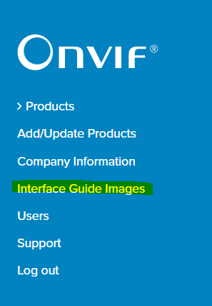

Clicking "Interface Guide Images" will take you to the following page where there are two sections, one for ONVIF images (handled by ONVIF) and the other one is for you to upload their own graphical assets.

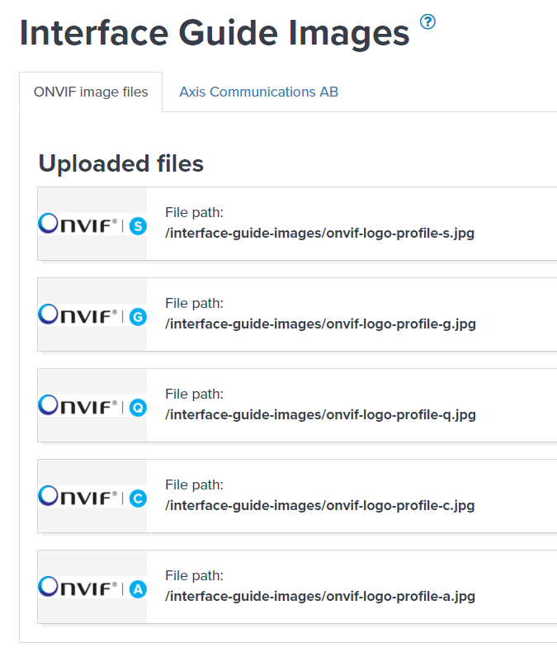

In the other section, you will be able to upload your images on your own and will see the "File path" to be used in your interface guide for images to show correctly.